CONTAINERS WEEKLY SCRIBE REPORT

Members: Ethan Henson, Triston Mobley, Eman Nawaz, Trevor Paige

# ROLES FOR ASSIGNMENT 2

Team Leader: Trevor Paige Team Member: Ethan Henson Team Scribe: Eman Nawaz Team Member: Triston Mobley

# MEETING INFORMATION

Our team met on October 19th from 2:30 - 3:00pm and October 27th 12:45 - 1:45pm via Discord. Trevor Paige, Ethan Henson, and Eman Nawaz were present.

# TOPICS COVERED

* 1. Schedule for completing the assignment was discussed
  2. Format of the assignment document was discussed

# ACCOMPLISHMENTS & CONTRIBUTIONS

* 1. Team Leader: Trevor Paige led the group and ensured all work including diagrams were sufficient
  2. Team Member: Ethan Henson completed his assigned portion of work
  3. Team Member: Triston Mobley completed his assigned portion of work

# RESPONSIBILITIES

* 1. Trevor Paige: Create and submit completed assignment document
  2. Eman Nawaz: Submit scribe report
  3. Ethan Henson: Complete assigned portion of work
  4. Triston Mobley: Complete assigned portion of work

**Part 1A and 1B - Classes and Attributes**

1. **Entity Classes**

|  |  |  |
| --- | --- | --- |
| **Entity Class** | **Attributes** | **Added By** |
| Package | Package ID, Weight, Destination Address, Contents, Delivery Status | Trevor Paige |
| Payment Transaction | Transaction ID, Amount, Payment Date/Time, Payment Status | Trevor Paige |
| Drone | Drone ID, Location Status, Availability | Eman Nawaz |
| Business | Business ID, Business Address | Eman Nawaz |
| Customer | Customer ID, Home Address | Ethan Henson |
| Account | Account ID, Account Settings, Order History | Triston Mobley |
| Item | Item ID, Price, Brand, Description | Triston Mobley |

1. **Boundary Classes**

|  |  |  |
| --- | --- | --- |
| **Boundary Class** | **Attributes** | **Added By** |
| Item/Cart UI | Product ID, Weight, Price, Cart Status, Contents | Trevor Paige |
| Account UI | User Info (name, address), Order history log | Eman Nawaz |
| Order Tracking UI | Order location, Estimated delivery time | Eman Nawaz |
| Search Request | Product ID, Search details | Ethan Henson |
| Login Page UI | Account ID, Password | Ethan Henson |
| Receipt | Order number, items from order, Amount to be paid | Triston Mobley |
| Tech Support UI | User credentials, Order number, User comments | Triston Mobley |

1. **Control Classes**

|  |  |  |
| --- | --- | --- |
| **Control Class** | **Attributes** | **Added By** |
| Customer Manager | Customer ID, Account ID, payment details | Trevor Paige |
| Security Manager | Authentication data, Account ID, system permissions, password | Trevor Paige |
| Order Transaction Manager | Transaction ID, Account ID, payment details | Eman Nawaz |
| Drone Tracking Manager | Drone ID, GPS location | Ethan Henson |

**Part 1C - Develop E-R Diagrams**

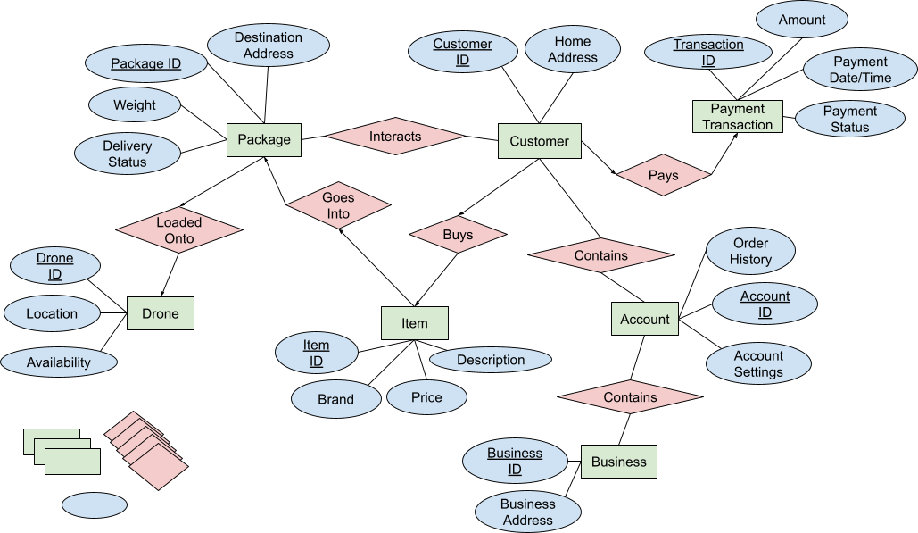**Entity Class E-R Diagram**

**Part 2 - Develop Level One Data Flow Diagram (Classical Approach)**

